

<DevOps Website Container On Cloud>

<SOI-2020-2010-0050>

Date of Submission: DD-MMM-YYYY

Submitted By:

<SOI-2020-0023>

|  |  |
| --- | --- |
| <18015536> | <Goh_Jun_Rui> |
| <18014587> | <Seo_Kai_Feng> |
| <18014868> | <Jeff_Poh> |
| <18015102> | <Jason_Choo> |

# ACKNOWLEDGEMENTS

***Section Explanation:*** *You may want to thank those individuals who have assisted your team during your project. You could also mention any organizations that have helped you while you have been carrying out the project.*

**TABLE OF CONTENTS**

ACKNOWLEDGEMENTS 2

ABSTRACT 4

1 Introduction 5

2 Project Specification and Plan 6

2.1 Project Overview 6

2.2 Functional Requirements 6

2.3 Project Plan 7

3 Business Analysis 8

3.1 Business Issues 8

3.2 Market Analysis 8

3.3 Business Solutions 8

4 System Design and Implementation 9

4.1 System Architecture 9

4.2 Detailed System Design 9

5 System Testing 10

6 User and Technical Documentations 11

6.1 User Documentation/Guide/Manual 11

6.2 Technical Documentation (Installation guide/Manual) 11

7 Conclusions 12

References 13

Appendices 14

Project Poster 15

# ABSTRACT

***Section Explanation:*** *The executive summary is also known as an abstract of your report. It is a brief summary of the report’s contents. It should be about half a page long (should be about 250 words or less). The reader should be able to understand what the project is about, how it was undertaken and what was accomplished. The abstract should answer the following questions:*

* *What is the project about?*

*This project is about us setting up an ECommerce website and launch it on cloud, With the help of DevOps Tools we learn how to use different methods to deploy our services into the cloud. (Kurbenetes, dockers etc).*

* *How is the project implemented?*

*We planned to implement our project with Google Cloud Kubernetes Engine and Prestashop docker container.*

* *What did the project accomplished?*

*We accomplished deploying our docker containers to cloud, our database, architectural*

*diagram and setting up kubernetes cluster. We also learnt many new skills such as azure cli, google cloud sdk, kubectl, docker, docker swarm, docker compose, github and kubernetes services.*

* *Final status of the project and recommendations (if any)?*

*Our final status of the project is currently in progress of solving our firewall issues which we had very little experience of solving firewall issues within cloud.*

# Introduction

***Section Explanation:*** *The introduction should tell the reader what your project is about. The introduction should answer the following questions:*

* *What exactly is the problem that your project is trying to solve?*

*Using automation to setup an e-commerce website and launch it on cloud. Setting up Docker compose, configure Kurbenetes and connecting the database in order for the website to be running well. Also to set the firewall so that the website would be secure too. This is to solve many of the issues websites faced being websites not automatically relaunching themselves whenever they met a crash or service wasn’t functioning as it was supposed to.*

* *Why is this problem important to solve? This is the motivation of the project.*

*This problem is important to solve because we can create automation to solve these issues so that we wouldn’t have the need to revisit them continuously and have to reboot the whole system daily which proves to be very troublesome. This motivates us even more as it is satisfying to see your own website setting up launching and restarting at a click on a button and you wouldn’t need to start each component by yourself every time the website launches.*

* *What are the major tasks and deliverables of the project? This is the project scope.*
  + *Running Docker Containers on LocalHost*
  + *Running Docker Containers on Cloud*
  + *Pushing Docker Containers to Cloud Container Registry*
  + *Setting up Kubernetes Cluster*
  + *Expose Deployments*
* *How have you solved the problem? This is your approach. You should expand on this in the later sections (project strategy, plan and design)*

*We designed Gantt Chart and made use of the scrum time schedule to work out our ideas. As this project modules are entirely new to us and it is a brand new component in IT which we have never explored before, using the SCRUM schedule we are able to develop our goals and progress along the way such that new ideas are formed during SCRUM meetings and using the AGILE Methodology, we are able to come up with a time frame for us to work on and continue our project even though we met a lot of huge obstacles along the way, we were able to overcome them.*

* *What are the conditions under which your solution is applicable? This is where you list the assumptions made, if any.*
  + *Unable to answer this question due to incompletion of Project.*
* *What are the main results? This is where you list the main deliverable points*
  + *Prestashop Running on LocalHost*
  + *Kubeneretes Cluster Created*
  + *Container Deployed*
  + *Exposed Deployment*
  + *Docker swarm on Localhost*

# Project Specification and Plan

***Section Explanation:*** *Students should read and understand the requirements in this section and set achievable deliverables with the Supervisor. Some of the deliverables that the students and Supervisors should agree upon before the start of the Project are listed below but not limited to:*

* *Extent of business analysis*
* *Extent of technical analysis, design and implementation*
* *Tools and techniques used in analysis*
* *Resources such as web server etc.*
* *Optional items listed in this guidelines that can be omitted from the report*

*This section should be completed between 1st and 2nd meeting*

* *Project Overview*
* *Functional Requirements*
* *Project Plan*

## Project Overview

***Section Explanation:*** *This subsection should contain a brief description of the system being developed and its purpose, including information such as:*

* *Project Motivation (Why do the project? what are the benefits?)*

*We do the project to explore how DevOps tools can reduce the time taken to launch the website and how it can be high availability and cluster for failover using DevOps tools. We also want to automate the website using script and launch its E-commerce platform for the sportswear on cloud.*

* *Project Objectives (What is the project trying to accomplish?)*

*We need a create a E-commerce website and design it with upload, delete, edit of website photos and details function. We need to create a customer database which can generate a list of what items, amount spent and date of purchase for the customers. At the same time, it can also generate a list of customers details like email, address, contact numbers. The E-commerce website should include a shopping cart and member registration. We will also make use of docker containers and upload them to the cloud so that the customers will be able to access them.*

* *Project Scope (What are the major tasks and deliverables of the project?)*
* *To be able to deploy our website into Cloud*
* *To be able to generate list of results from the database*
* *To be able to use automation (kubernetes) to launch the website*
* *Project Assumptions (Are there assumptions which are made regarding how the end deliverable will work, etc.?)*
  + *We had a goal in mind which seems unattainable at first with all the obstacles we had to go through. But it seems really close to us now and we almost made it succeed.*
  + *We assumed too early everything is just very smooth sailing and we could set up our very own cloud website with the assistance of devOps but we were very wrong when we were stuck with multiple errors and many different commands .*

## Functional Requirements

***Section Explanation:*** *This subsection should clearly specify the major functions the system should possess. Business rules or business requirements must be documented. Students are encourage to use tools such as Use Case diagram to document the business requirements.*

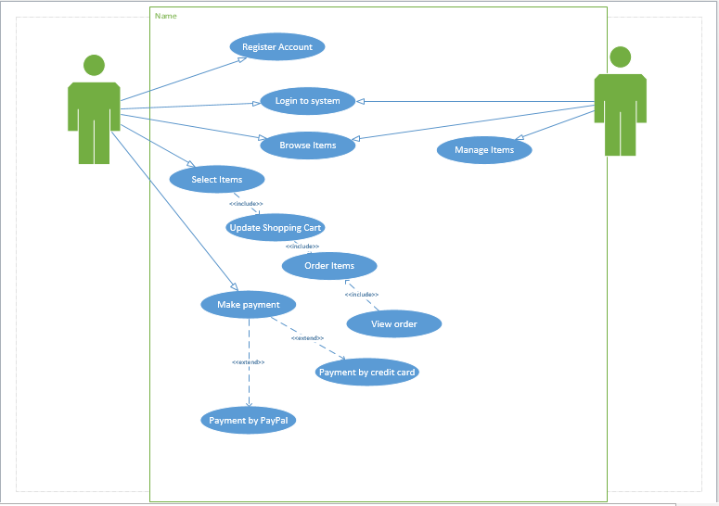

## Project Plan

***Section Explanation:*** *This subsection describes in detail the schedule, milestones and work allocation of each member of the team. Care must be taken to prepare this as each member of the team will be evaluated independently based on his/her contribution, effort, teamwork amongst other factors. This subsection will also serve as a basis where teams and supervisors can monitor progress being made. The use of MS Project is recommended.*

*In the Microsoft Project, you may include the following:*

* *List of tasks need to be assigned to a particular team member*
* *Ensure that there is adequate and fair involvement by each team member*

*In the Microsoft Project, task are assigned fairly to all team members. The days given to complete the task is also reasonable. Even*

* *Project Plan must take into consideration the deliverables at specific milestone such as the 3 meetings*

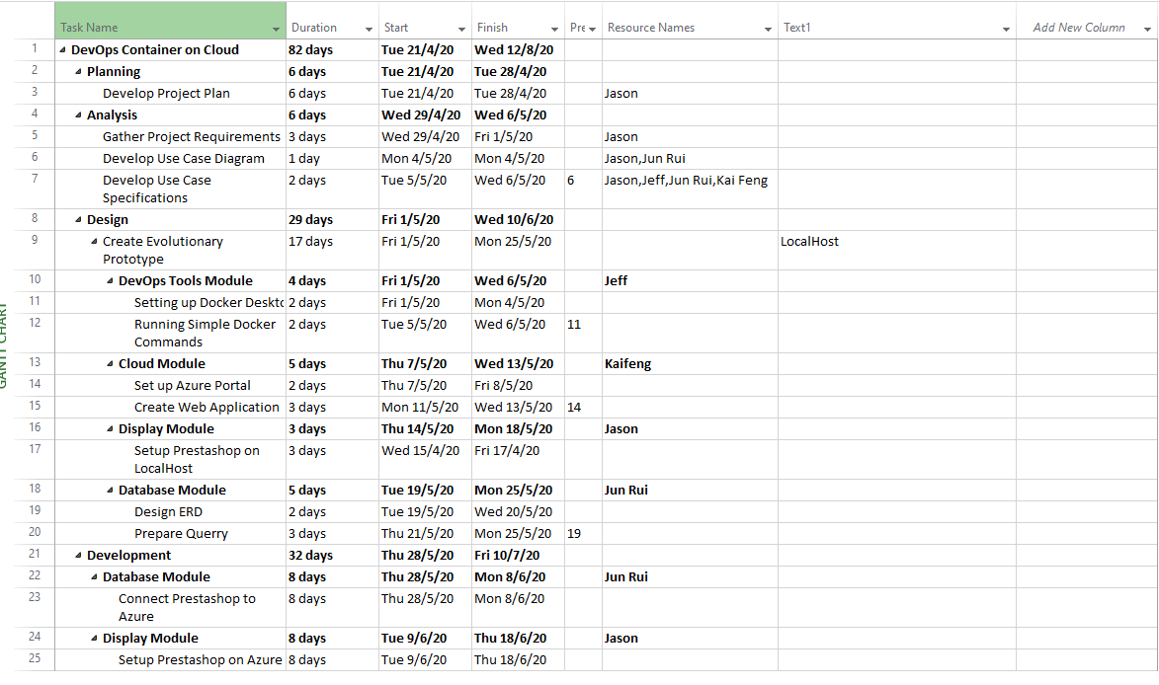

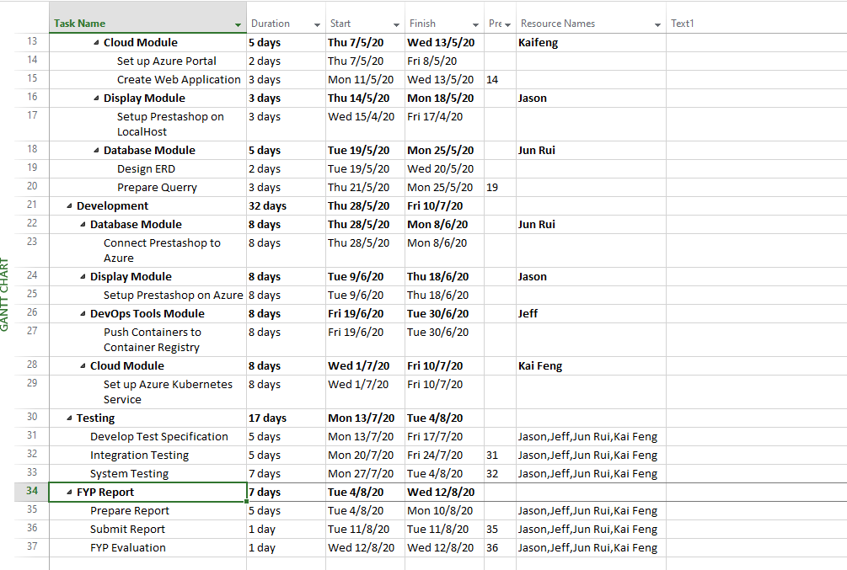

# Business Analysis

***Section Explanation:*** *This section is applicable to projects in domains such as Application Development, Data Analytics & Visualisation, IoT (Sensor driven applications), IT Security, Mobile App, and Solution Implementation.*

*This subsection describes the business analysis done to address the business issues of the project. It should contain the following but not limited to:*

* *Business Issues & Market Analysis (optional, Supervisor to decide)*
* *Business Solutions*

*We use google cloud for our cloud module, MYSQL workbench for Database module, prestashop for display module, Docker for DevOps tools module.*

## Business Issues

***Section Explanation:*** *This subsection describes the current business situation with special emphasis on the issues that the project is trying to solve. Some consideration includes:*

* *Provide more detail on the current situation*
* *Company Azure, a small startup which is planning to launch its sales E-commerce platform for their sportswear on cloud. This would be a tedious process as it would involve a certain amount of coding for the website creation and the costing of servers that it would need to maintain. There is a pending need to cut down the time taken to launch the website. In additional the servers need not to be maintained and should allow certain features i.e. HA (High availability), clustering for failover..etc Year lead has done some research and suggested using DevOps tools and AWS cloud to meet the above requirements. Even though the human touch on initial configuration cannot be replaced by machines/automation. The E-commerce website service must be able to be launched automatically using script.*
* *What are the difficulties or business issues that we are trying to solve?*
* *Make use of DevOps tool and cloud to publish E-Commerce website with automation*

## Market Analysis

***Section Explanation:*** *This subsection describes the size of the business solution. The following may be included in this subsection:*

* *Size of business and market segment*
* *Competitive analysis*
  + *Unable to answer this question due to incompletion of Project.*

## Business Solutions

***Section Explanation:*** *This subsection describes the business solution to the problem. Students are expected to demonstrate their ability in understanding the business logic and the process. Some important consideration is to understand the overall business process and not just the IT solution. The following may be included in this subsection*

* *Process flow*
* *How IT can help*
  + *Unable to answer this question due to incompletion of Project.*

# System Design and Implementation

***Section Explanation:*** *This section describes the architecture and the design of the system. It will briefly describe the various hardware and network interaction.*

*The Azure Architecture*

* *It was our original plan before the Mid Semester and during the holidays. This was the architecture diagram we came up with.*
* *With the App service plan and our docker container registry working together we were able to launch prestashop*
* *However, in the mid semester period, we were tasked to challenge ourselves further and work on kubernetes which deemed to be difficult to configure but we came up with an architecture diagram. A plan to go on with.*
* *We tried our hardest but we couldn’t get the kubernetes to work as we had a limit of 1 node instead of 3 due to it being a free trial account.*
* *We couldn’t get to connect to our kubernetes cluster and was struggling*
* *This led us to our next progression.*

*Google Kubernetes Engine.*

* *We got kubernetes engine to work over here*
* *We designed the architecture diagram such that it works around the load balancer for the nodes/pods.*
* *We have pushed our docker container to our container registry and had the container engine pull those images.*
* *Next we deploy them through kubernetes and a load balancer to the nodes/pods.*
* *We have our cloud storage which is mysql.*

## System Architecture

***Section Explanation:*** *This subsection describes the interaction between the different hardware. At the same time, it will describe the network topology that will be used by the system.*

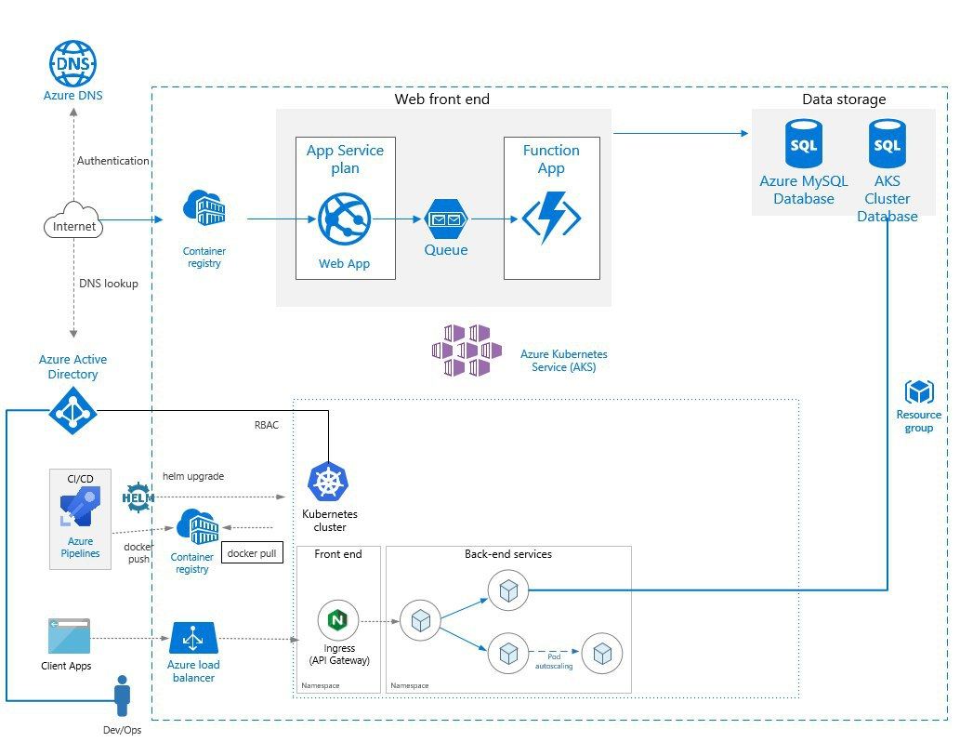

* *This was supposedly to be our architecture diagram for our resource group project ECL*
* *However, We couldn’t get to deploy AKS but this was what we had in mind before.*

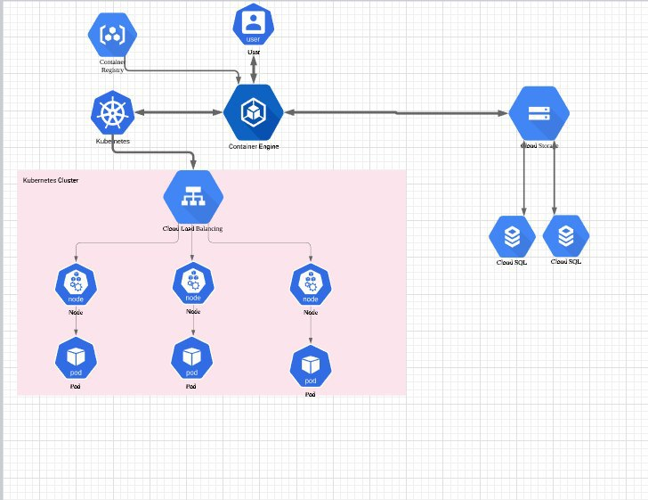

* *This is our current architecture diagram with google cloud.*
* *The Google Kubernetes Engine allow us to simplify our diagram due to the google cloud having an excellent load balancer.*

## Detailed System Design

***Section Explanation:*** *This subsection includes the design documentation for the project. Care must be taken to ensure that the diagrams are clear and carefully organized.*

* *The following tools can be used to help in design:*
* *Entity Relationship Diagram*

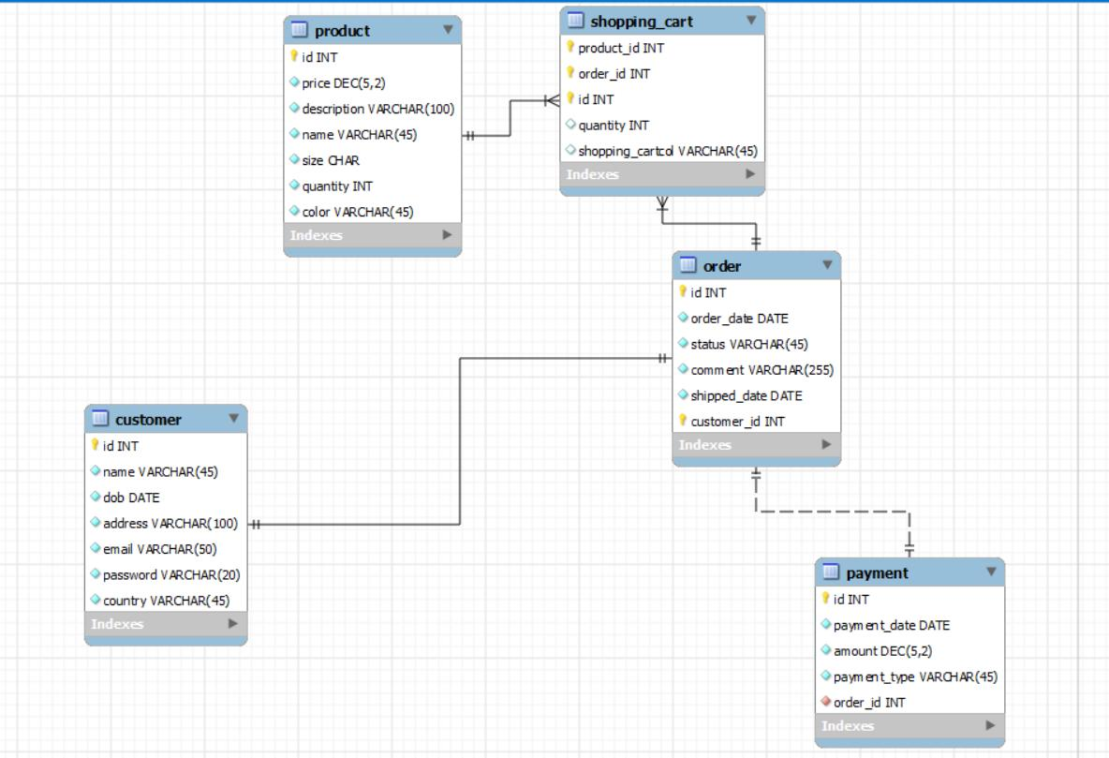

* *Use Case Specification*

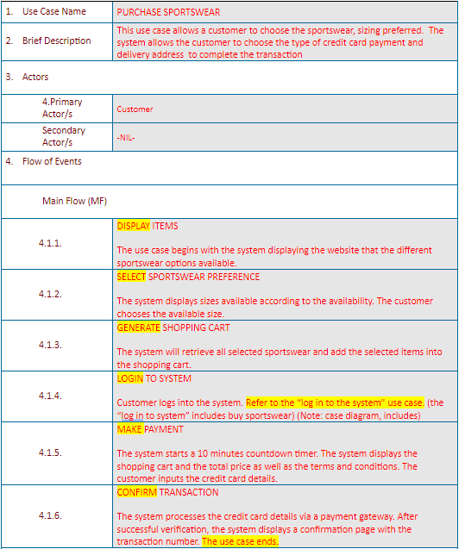

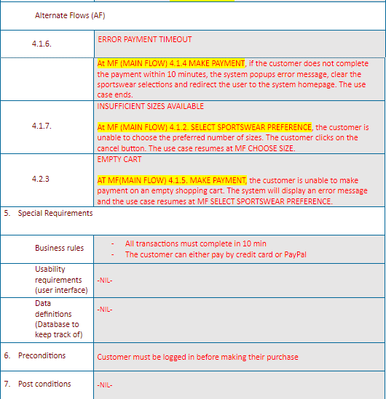

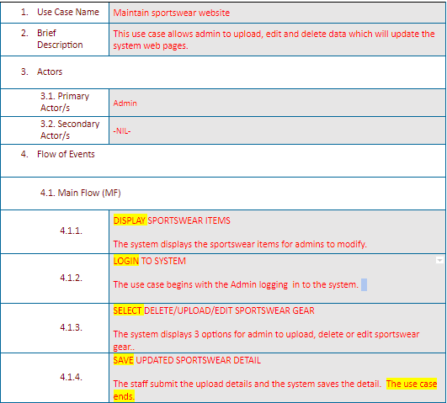

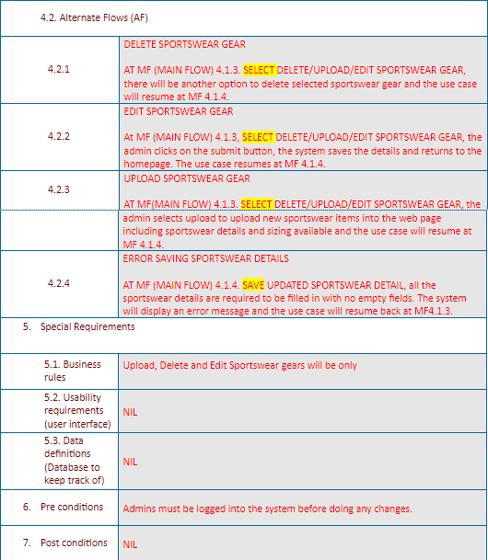

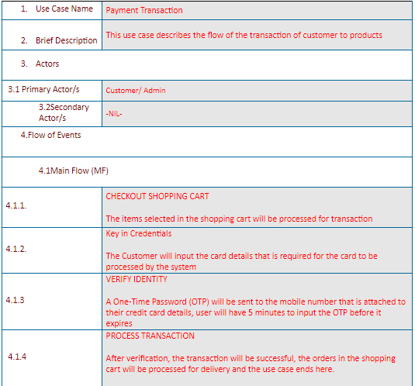

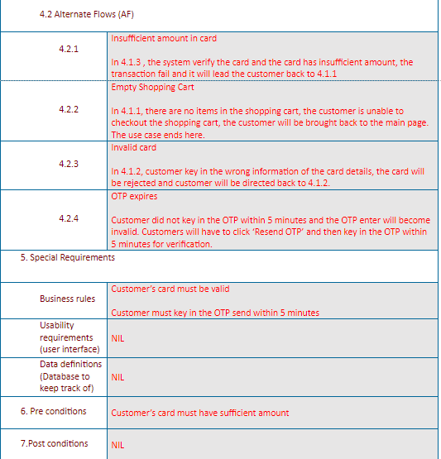

* *Unified Modelling Language Tools (e.g. Class Diagram, Sequence Diagram, only for OOP project)*
* *Gantt Chart*

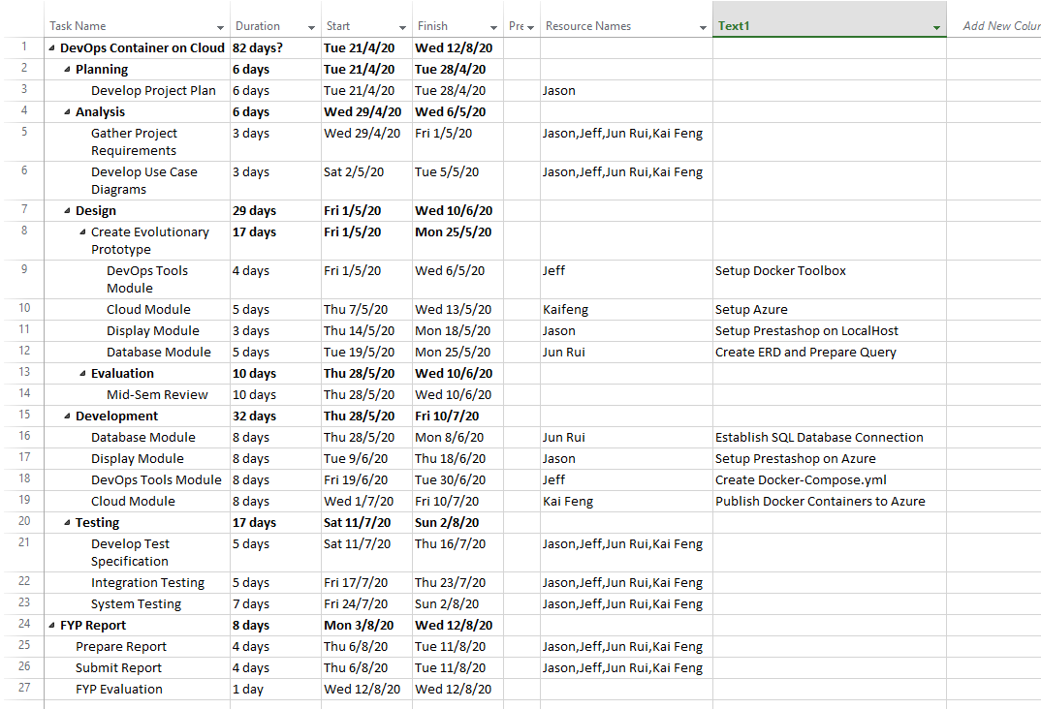

* *Data Flow Diagram*
* *Control Flow Chart*
* *Decision Table/Tree*
* *Pseudo Code*

# System Testing

***Section Explanation:*** *This section describes how the system will be tested for robustness and fulfilment of functional and system requirements (Test Plan).*

*You may use the Sample Test plan for reference, and use RP Test Specification Template for Unit / Functional Testing.*

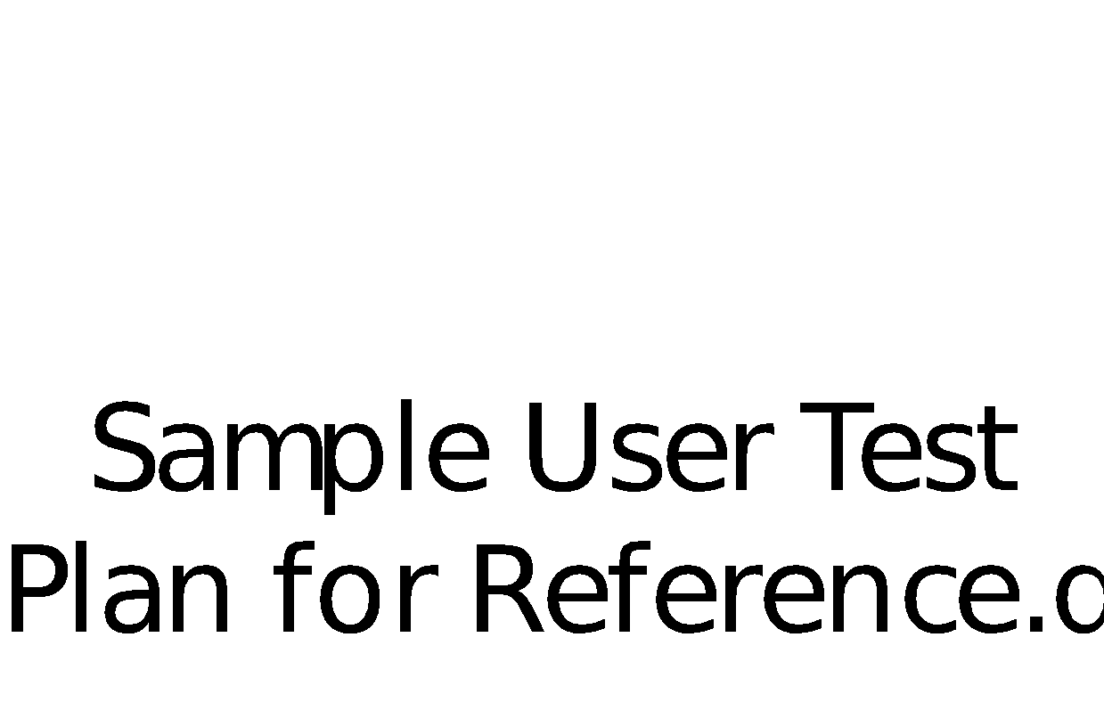 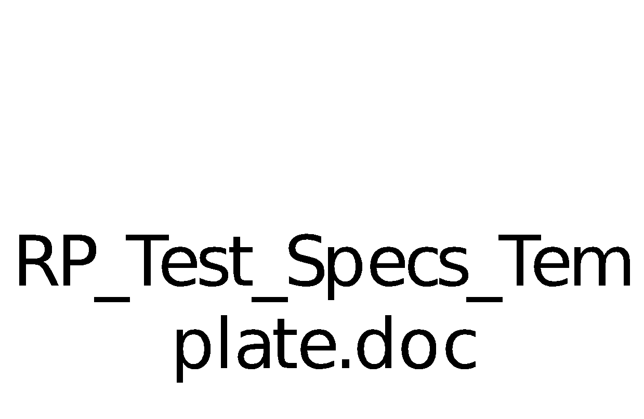

From Freelancer.com

(formerly RentACoder.com)

*Other Resources for reference on Software Debugging and Testing:*

[*https://en.wikipedia.org/wiki/Software_testing*](https://en.wikipedia.org/wiki/Software_testing)

[*https://braydie.gitbooks.io/how-to-be-a-programmer/content/*](https://braydie.gitbooks.io/how-to-be-a-programmer/content/)

[*http://www.extremeprogramming.org/rules/unittests.html*](http://www.extremeprogramming.org/rules/unittests.html)

# User and Technical Documentations

## User Documentation/Guide/Manual

***Section Explanation:*** *A user documentation or manual should be produced to describe how the system should be used. It should be readable and understandable by a non-technical person (i.e. someone who is IT illiterate). Illustrations and graphics can be used to great advantage here.*

* + *Unable to answer this question due to incompletion of Project.*

## Technical Documentation (Installation guide/Manual)

# Conclusions

***Section Explanation:*** *This is the section where you should state the main take-away points from your project. It should be more information than the abstract. You should include a concise version of your accomplishments, what problems you had, and what could be done in the future to rectify them.*

* *Summary of Accomplishments*
  + *We learnt Azure CLI*
  + *We were able to deploy containers to cloud web app service*
  + *We were able to understand what Azure Kubernetes Service is*
  + *We know how to deploy docker containers in LocalHost*
  + *We know how to organise out a project*
* *Future Work*
  + *We had no guidance from anyone, so this project was also not taught before regarding DevOps Tool and Cloud Service Provider. Hence, everything was based on research and started from scratch. Our Supervisor did not know what was Kubernetes Service until we explained to him. So actually we think it was a very good progress with no proper guidance and support.*

# References

* **Acknowledge** any work, statement or definitions copied
* Citation **style**
  + IEEE citation style
    - [1] D. Ingre, *Survivor’s guide to Technical Writing.* Mason, OH: South-Western Educational, 2003.
    - Usage: Some text. [1]
  + APA citation style
    - Dubeck, L. (1990). Science fiction aids science teaching. *Physics* T*eacher, 28,* 316-318.
    - Usage: Some text. (Dubeck, 1990)
  + MLA citation style
    - James, Nancy E. "Two Sides of Paradise: The Eden Myth According to      Kirk and Spock." Spectrum of the Fantastic. Ed. Donald Palumbo.      Westport: Greenwood, 1988. 219-223.
    - Usage: Some Text. (James 1)

# Appendices

***Section Explanation:*** *This is for you to include materials which you could not put in the main body of your report. For example, you could include source code of your project.*

*Appendices should be headed by letters in alphabetical order, ie. Appendix A, Appendix B, etc.*

# Project Poster

***Section Explanation:*** *Pls create a poster write-up for your project. The file should be saved as a PPT file and embedded in this section as an object.*

**